Humanities Art
Institution Affiliation
Course Title
Date.

Humanities refer to academic disciplines that usually study aspects of human beings' culture and society. They include studying both the olden and modern languages, philosophy, human geography, religion, literature, anthropology, art, and archaeology. However, humanities help individuals decide on what is essential in their lives and what they can do to make their lives much better. On the other hand, ArtArt refers to any product or activity done by humans with either a communicative or aesthetic importance. In other words, ArtArt is something that is used to express a person's idea, emotions, or generally the world view. In turn, art is a component of culture that reflects both economic and social substrates in its design. However, ArtArt is part of humanities, and it includes visual arts like sculpture, painting, and acting out arts such as dance and drama. Some societies like language are considered as arts, for instance, the language arts. Therefore, humanities and arts are essential as their study enables profound intercultural knowledge and lay the basis for a civically engaging life. Also, they prepare people to think critically and act creatively, which leads to success in this rapidly changing world.
The eldest sheltered human ArtArt is found dates to the late stone age during the Upper Paleolithic period. This is approximately seventy thousand BC from when the first works of creativity were made from stones, paint, and shell by Homo sapiens. The paleolithic period was, however, an age of hunting and gathering—the following images of ArtArt during the Paleolithic period.
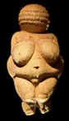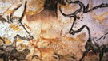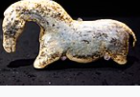
The Mesolithic period is between the Neolithic period and the Upper Paleolithic period. During this period, humans continued the arts formed during the Paleolithic period, such as the painting of the caves, engravings, trivial sculptural artifacts, and ceramics. All these arts reflected their lives. This period is marked by the development of agriculture and permanent human settlements. The following are some of the images of ArtArt during this period.
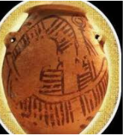
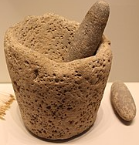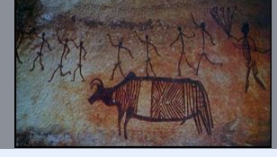
The Neolithic age is the last period of the Stone Age. This period is characterized by the domestication of both plants and animals and the usage of weapons made of bones and polished stones. The following are images of ArtArt during this period.
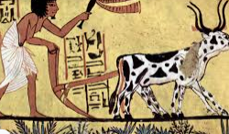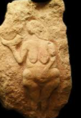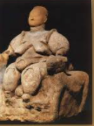
Art is an essential part of human beings, and there are so many reasons why humans create works of art. Some of these reasons are; first, making the surroundings more beautiful. Making objects beautify the humans' environment has been the greatest motivation to create numerous kinds of arts—jewelry, sculpture, painting, etc. Second, Arts help keep records of specific time, place, object, and persons and, for instance, take photographs during occasions such as a wedding, painting of persons, etc. Lastly, ArtArt helps express and communicate ideas. These includes the ArtArt made for enlightening people or the ones for conveying sacred beliefs.
One of the areas of arts addressed in the textbook is painting ArtArt. Painting helps express emotions and ideas together with the formation of certain artistic qualities in a two-dimensional graphical dialect. The elements of this dialect include shapes, tones, textures, and colors used in numerous ways to yield sensations of space, light, volume, and movement on a level surface. Moreover, painting helps foster innovative growth, creates problem-solving skills, and helps strengthen memory. The following are images of some famous paintings.
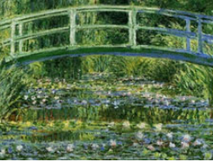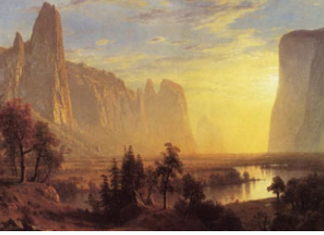
https://www.brushwiz.com/most-famous-paintings/
Inclusion, humanities gives people a chance to experience distinct ideas, influence them to evaluate their values, and motivate them to challenge their beliefs. However, societies allow humans to understand each other by facilitating open-mindedness and revealing culture and empowering them to share their individual differences to discover their commonalities. Therefore, humanities are essential aspects of human civilization as they help people learn many different cultures' values.
Reference
Guetzkow, J. (2002). How the arts impact communities. Centre for Arts and Cultural Policy Studies, 7-8.
Levitt, R., Celia, C., Diepeveen, S., Chonaill, S. N., Rabinovich, L., & Tiessen, J. (2010). Assessing the Impact of Arts and Humanities Research at the University of Cambridge. Technical Report. RAND Corporation.
Lynch, G. H. (2012). The importance of ArtArt in child development. PBSparents. Recuperado de http://www. PBS. org/parents/education/music-arts/the-importance-of-art-in-child-development.
Links
https://www.brushwiz.com/most-famous-paintings/
https://www.jagranjosh.com/general-knowledge/the-neolithic-age-1430564528-1
https://courses.lumenlearning.com/boundless-arthistory/chapter/the-mesolithic-period/#:~:text=Mesolithic%20people%20likely%20continued%20the,artifacts%20%2C%20and%20early%20megalithic%20architecture.

